Fun quiz. Look at this picture, which animal do you see first?
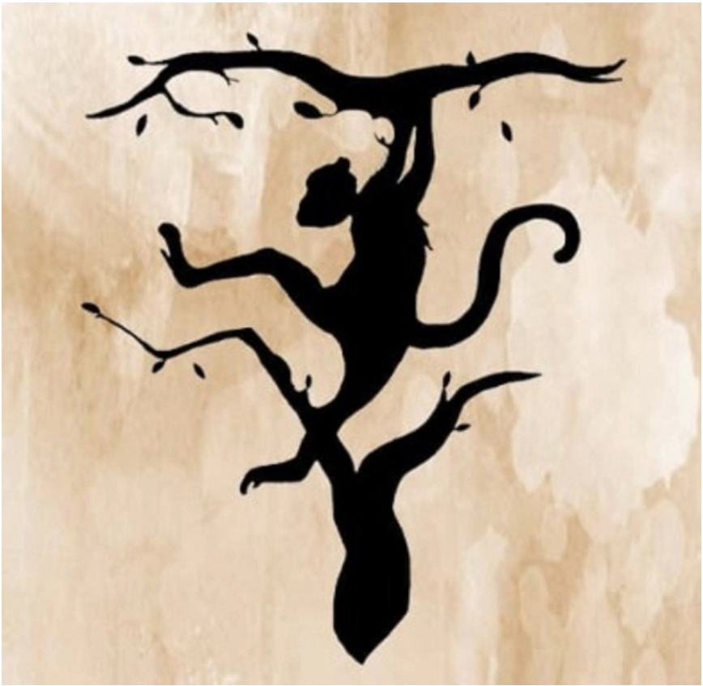
Nobel Prize-winning psychologist Roger W. Sperry discovered that our brains’ left and right hemispheres have different functions, so the way you think depends on which hemisphere is dominant. Based on his research, there are many tests that can determine your thought processes and personality traits.

- The Head of a Tiger
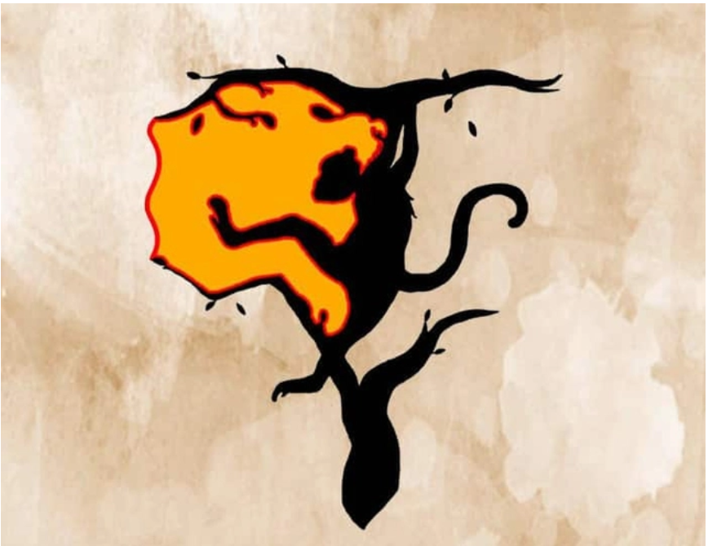
Your left brain is more developed. You are analytical, goal-oriented and organized. When faced with a problem, you tend to solve it logically, calculatingly and objectively.
You are a determined person because you know that your decision is the result of hours of thinking and consideration. So the advice is to listen, consider other people's opinions and remember, a little humility will go a long way.
Your personality traits:
1. Planful: You do everything according to plan, everything is listed in the to-do list.
2. Precise: You have clear goals and know the path to achieve them.
3. Rational: Emotions cannot stop you from achieving your goals.
4. Logical: You are gifted in mathematics, science and organizing ideas.
5. Realistic: The world in your eyes is very real. There is no room for fairy tales and novels. While your goals may seem far-fetched to others, you know they are realistic and achievable.
2. A Monkey
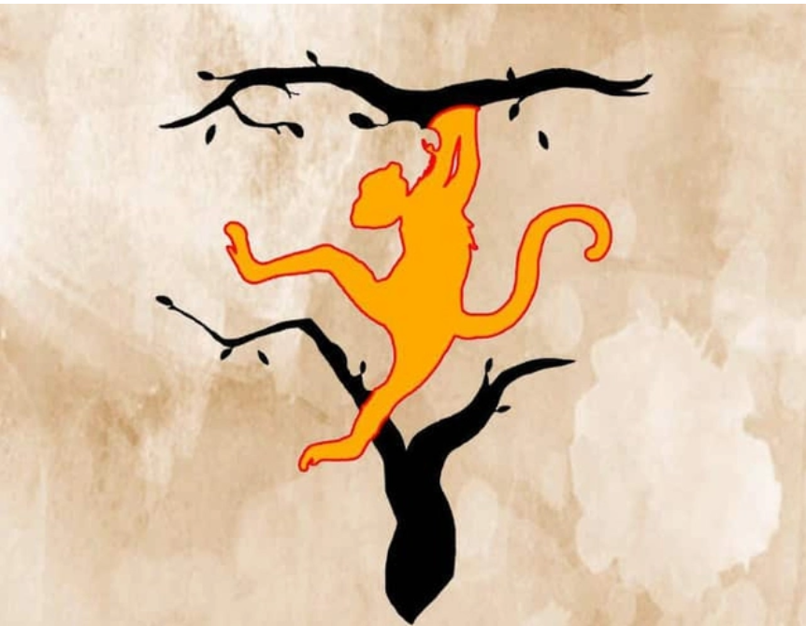
Your right brain is more developed. You are full of creative ideas in your head. When dealing with problems, you use your intuition more than your reason.
You know very well that every step in life is a lesson and even failures are stepping stones to achieving your goals. For you, the luggage is more important than the prize. Because you are a dreamer, you often get lost in your own land. Sometimes you need to be a little more practical to pay more attention to the world around you.
Your personality traits:
1. Impulsive: You are very spontaneous in everything. You have creative, new, groundbreaking thoughts, not following the old ways.
2. Emotional: You are interested in many things. You spend time reflecting and acting on emotions.
3. Creative and artistic: You are skilled in music, art and other creative fields.
4. Intuition: You don’t make to-do lists and you don’t like to follow rules. You solve problems intuitively.

5. Dreamer: You have more dreams for your life than specific goals and you work hard to achieve them.

Remember that the two hemispheres of the brain do not work independently, but instead work together and complement each other. So, you may possess more than one of the characteristics of either the right or left hemisphere. How do you feel about the test above?

